A tidbit about including dates in footers Office 20102007:

When you want to include a date in a footer, you have the option of having the date fixed (maybe the date the file was created) OR having the date automatically update each time the file is opened. It is only a matter of choosing the option when including the date.

Office 2010 gives you several templates for the footer when you Insert/Footer – 1. blank (with 1 space on left),

2. blank with 3 space – left, center, right

3. alphabet (with 1 space on left and automatic page number on right), and

4. annual (automatic page number on left)

The only difference between 2010 and 2007 is that 2007 does not offer the last option (annual)

After you choose which template you want to use, you can “Edit” the footer and enter the information desired.

Note that your options on the top ribbon have changed when you click on the footer for editing. If you choose Alphabet, you can enter text (or a date) in the left space. One of the options on the ribbon is Date&Time. If you click on this option, you will see the following

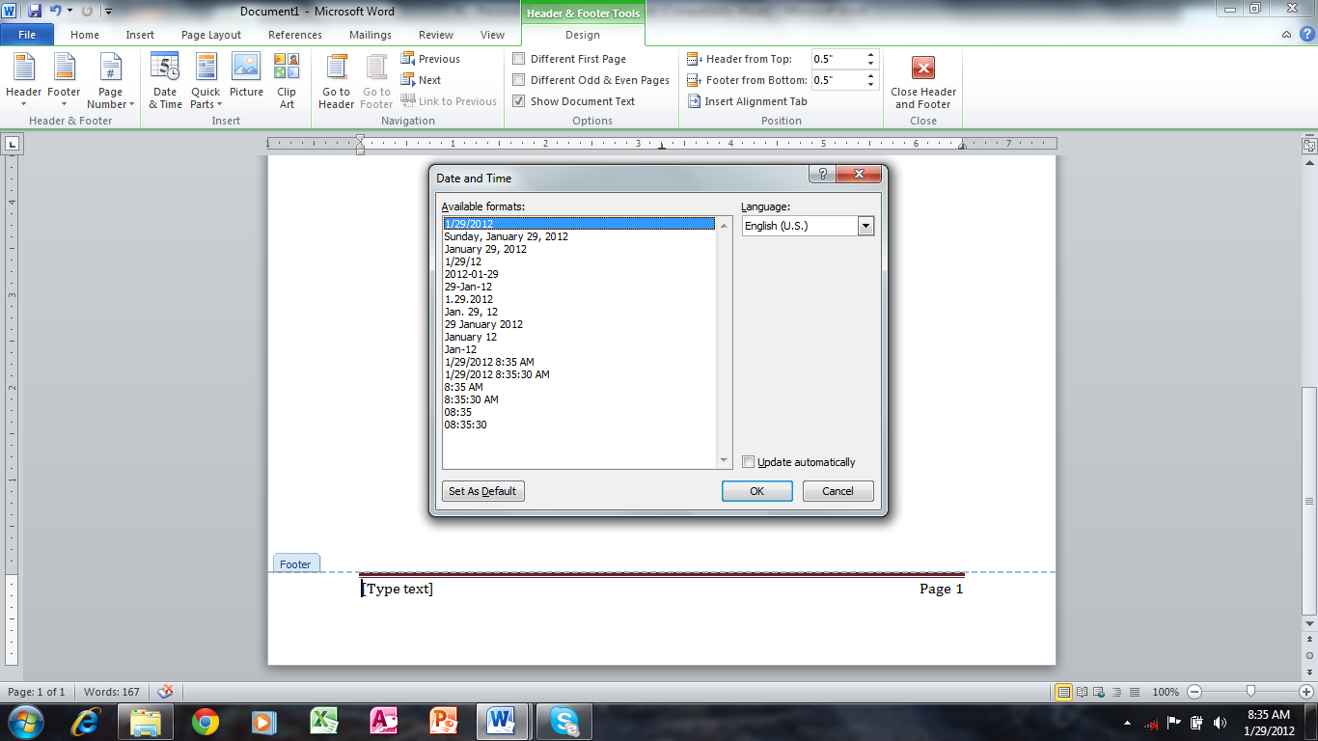

Note the option in the lower right corner – Update automatically. If you simply select a date format from the left window, it will be a fixed date. If you check the box in the lower right, the date will automatically update to the current date each time the file is opened.

This particular file has a FIXED date – it should always display as 1/29/2012.